**Journey planner research**

**Journey Organizer**

**<1.0>**

|  |  |  |  |  |
| --- | --- | --- | --- | --- |
| **Version** | **Date** | **Author** | **Approved by** | **Description** |
| 1.0 | 12/11/2015 | Karol Baran | - | Reviewed 3 different, popular route planning systems |

**Table of contents**

1. Introduction3
2. Reviews3-8

2.1 TFL Journey Planner3-6

2.2 National Rail Journey Planner6-7

2.3 Stagecoach Plan a Journey7-8

1. Evaluation9
2. **Introduction**

In this document I will look at and review some of the popular route planning websites. I will look at the basic and advanced features offered by those systems, talk about their layout and design and review their usability and simplicity.

The purpose of this research is to get ideas and inspiration for the features and design that could be implemented our system. In this document I am only going to focus on the route planning features included in the reviewed websites and ignore all of the other features.

1. **Reviews**

**2.1 TFL Journey Planner**

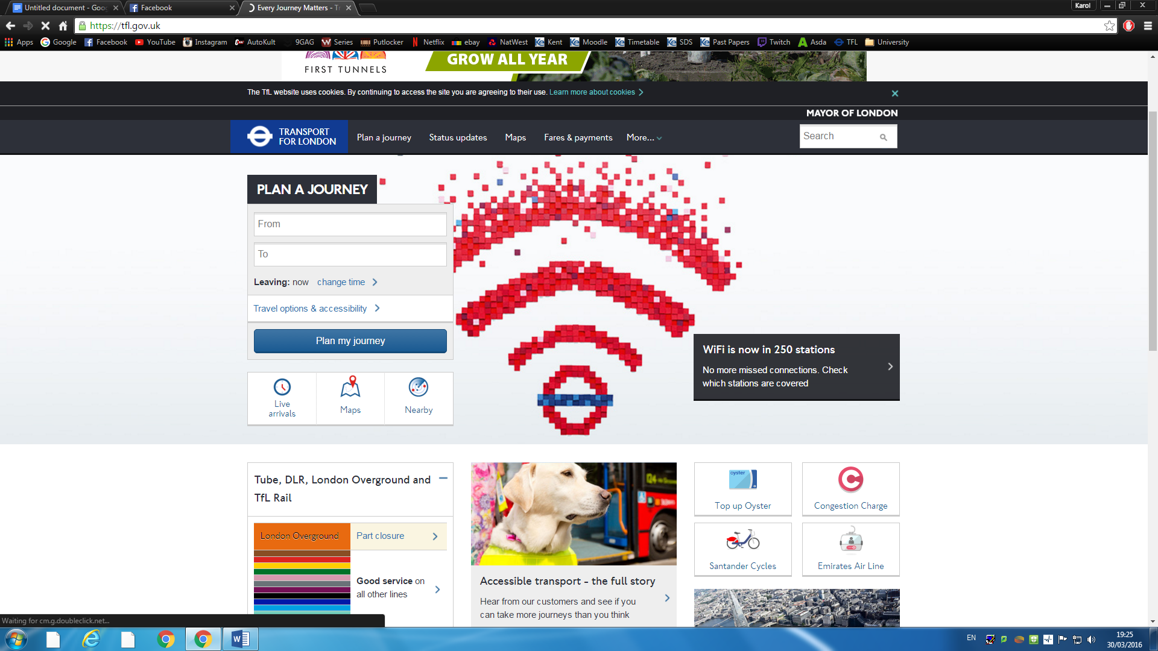

Initial appearance of the journey planner appears minimalistic offering just the input for initial location and destination.

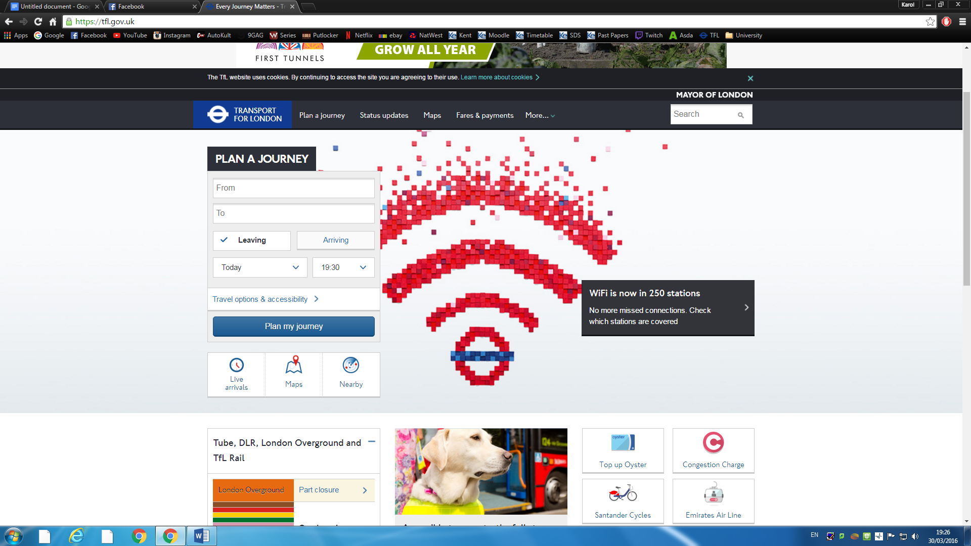

There is an extra button/link “change time” which extends the form and offer users the ability alter the time as well as determine whether that time is specified for an arrival or departure.

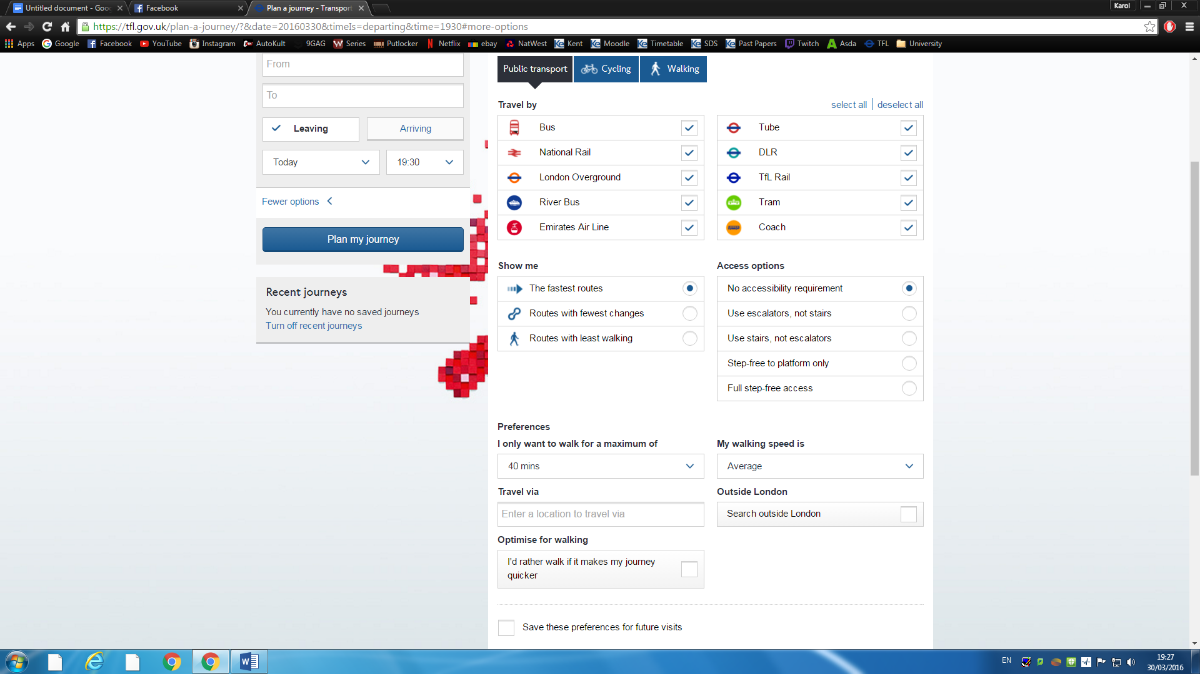

Clicking on the “Travel options & accessibility” button shows the “change time” options as well as a large number of further routing and transport options. A user can now determine discrete transport choices, route sort and selection and accessibility options.

There are also 2 additional tabs in the “Travel options & accessibility” menu for walking and cycling where users can select their walking speed and desired use for a bicycle respectively.

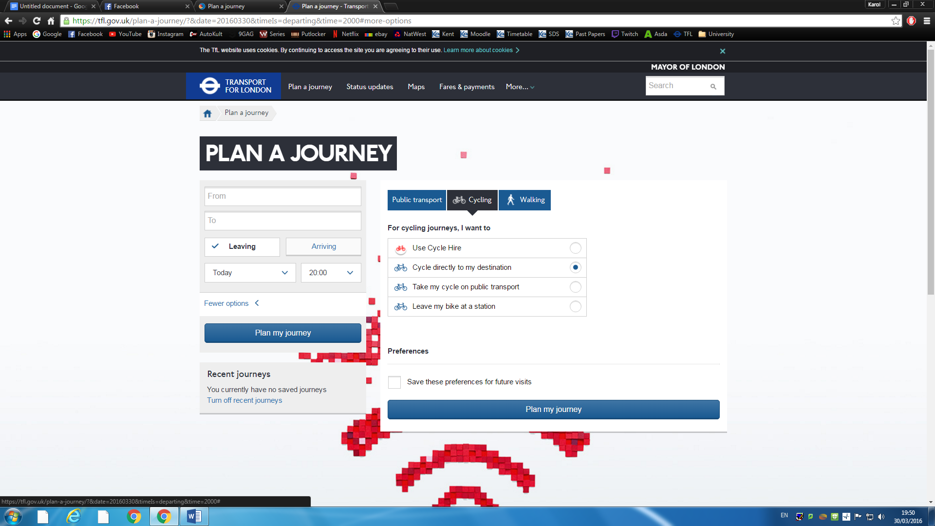 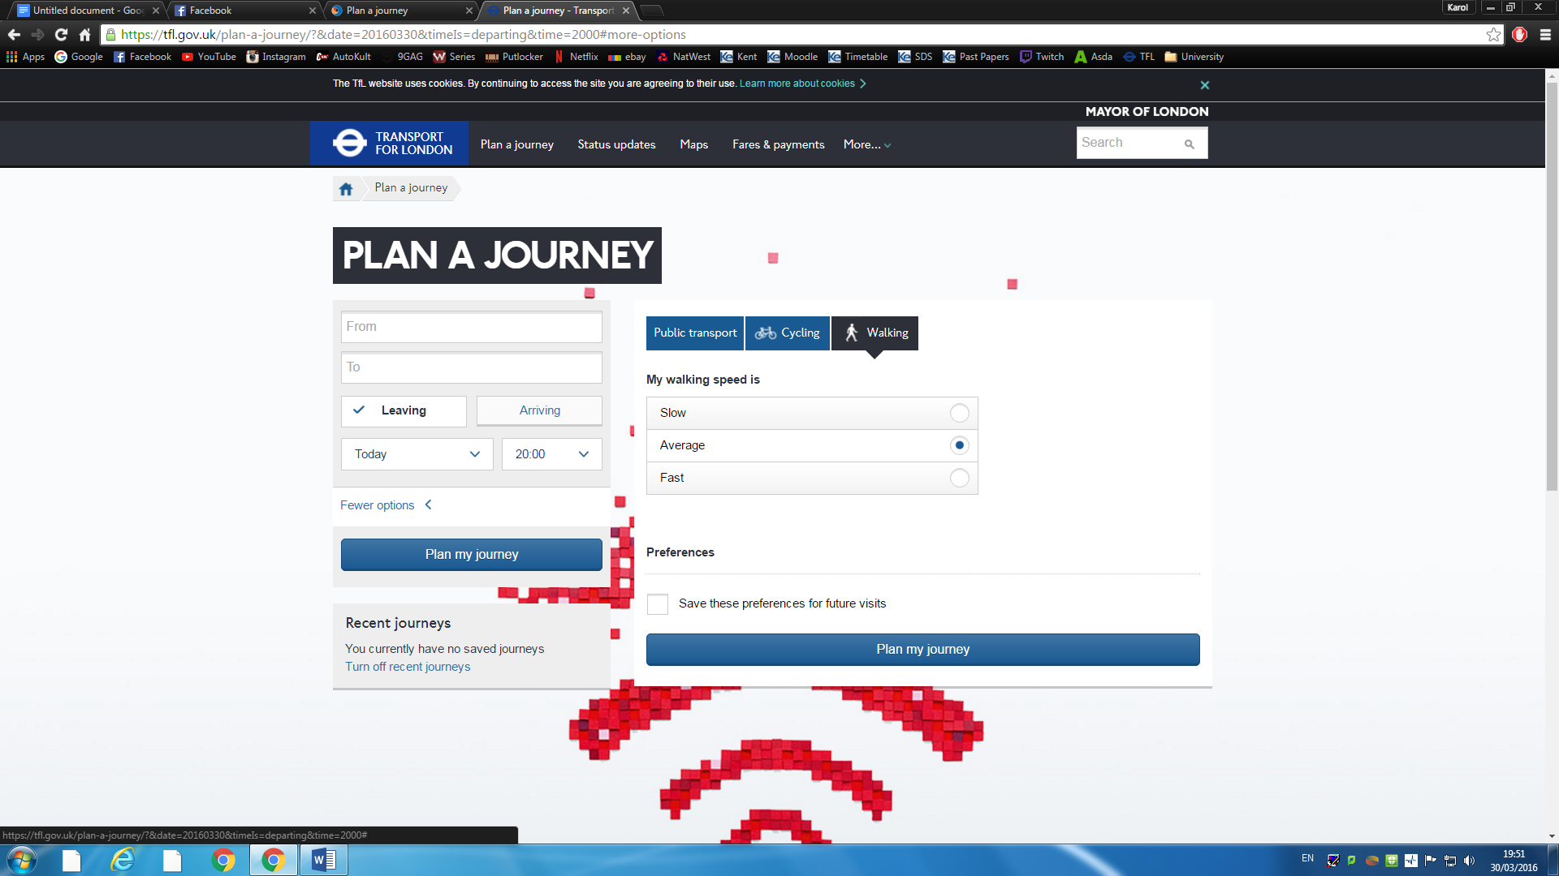

TFL’s journey planner is implemented nicely. It is very simple and easy to use at its most basic level, however it also offers variety of travel options in an advanced options section. I have personally used this system a number of times, leading me to a conclusion that it is reliable and usable. Furthermore it is the only reviewed system that also implements cycling and walking as a travel choice making it similar to the system that we plan to create.

**2.2 National Rail Journey Planner**

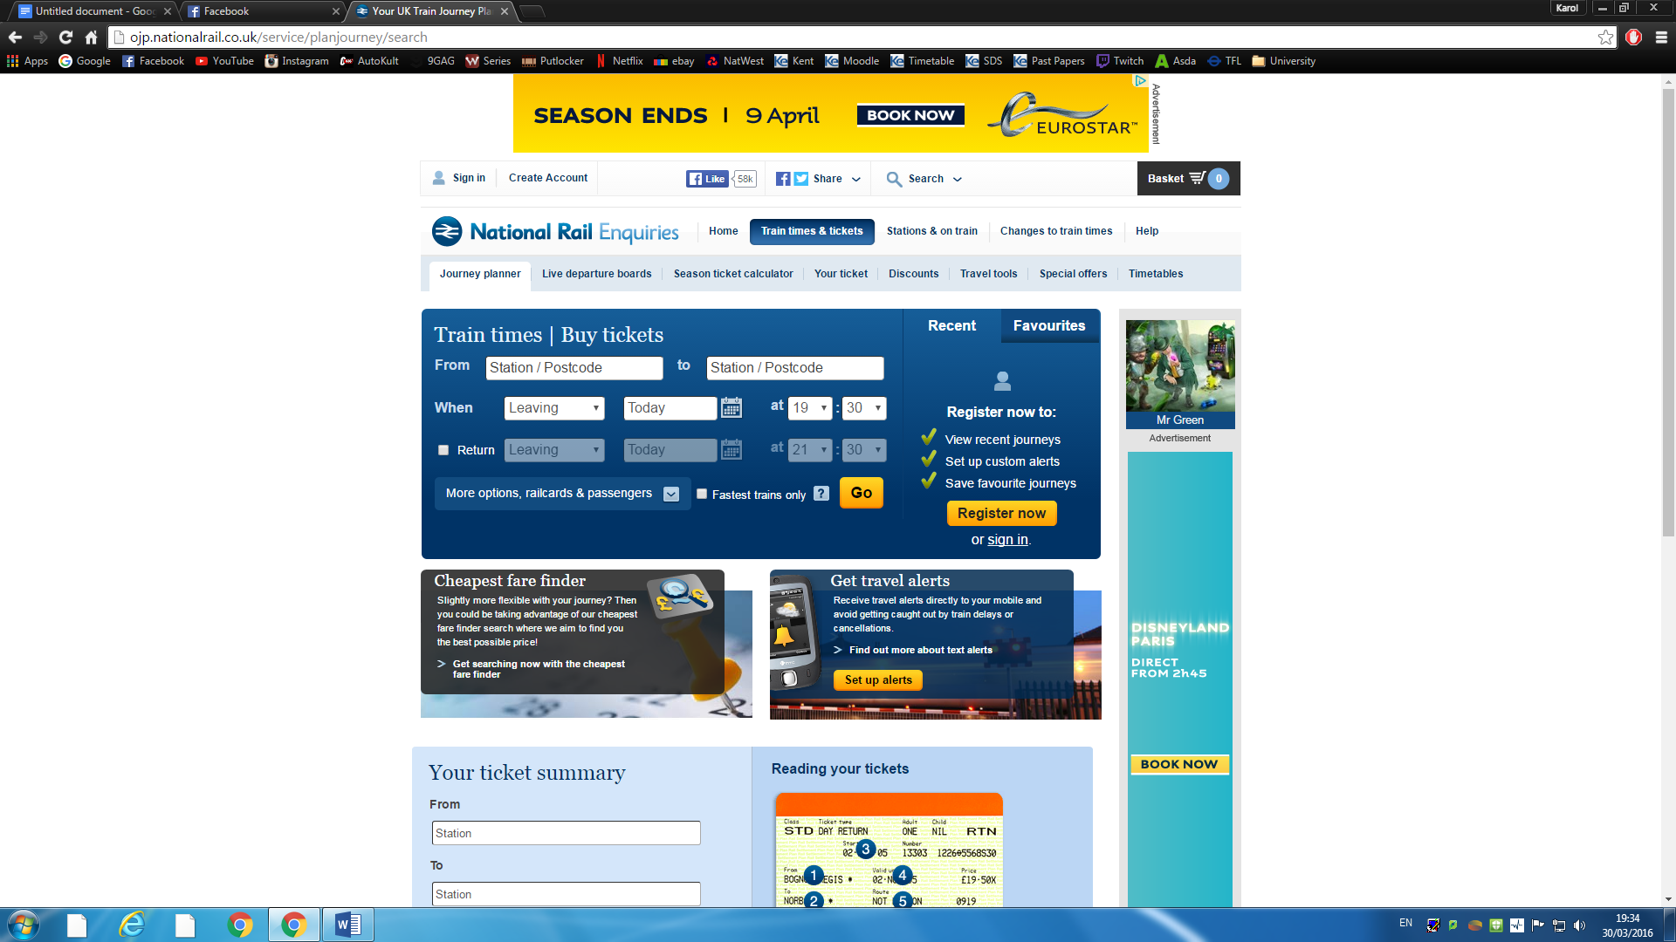

At first glance the National Rail route planning system looks a little messy. The styling is very minimalistic and the basic layout offers pretty standard initial location and destination input boxes and timing options. There is also an optional return journey planner.

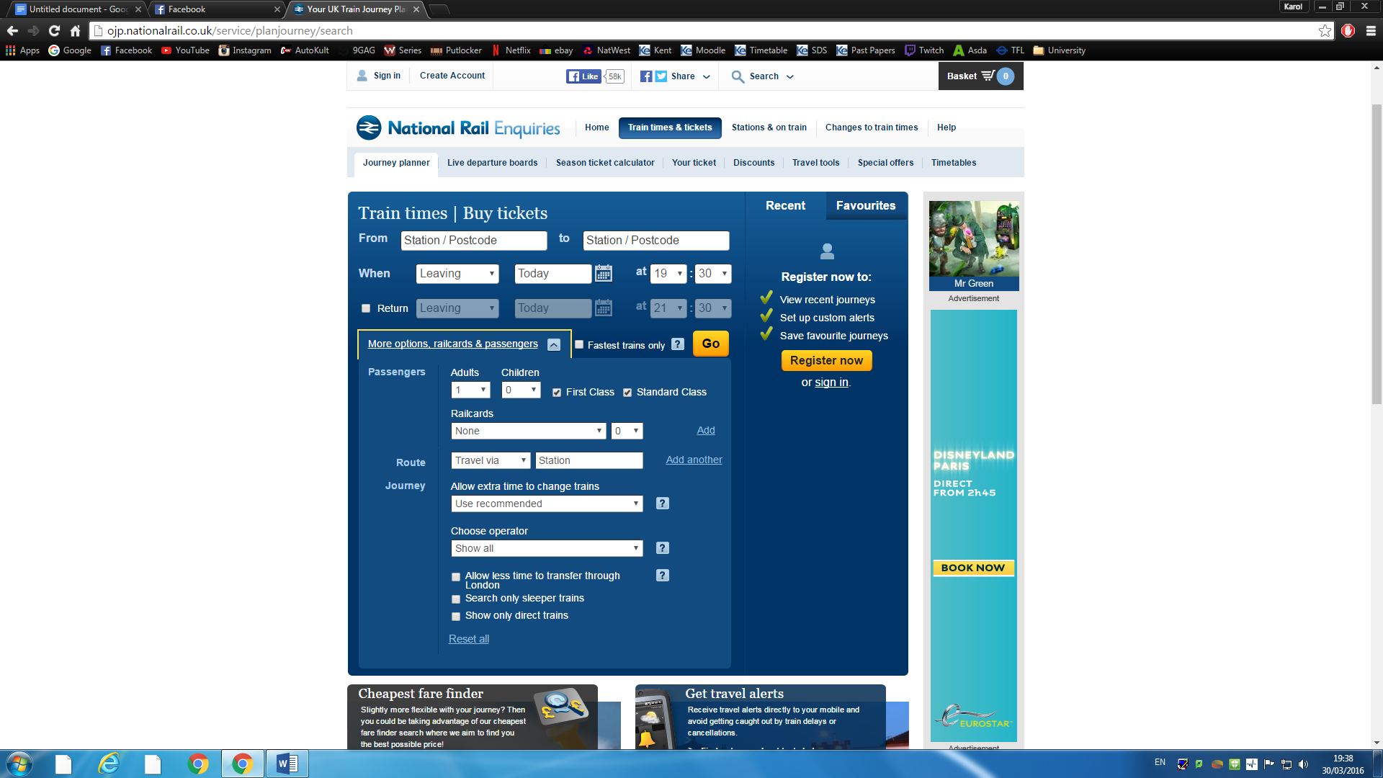

This route planner also has a button to display more options for input such as number of passengers, class system, rail-cards etc. The advanced options in this system are largely irrelevant to the system that we are going to produce.

This system only focuses on trains therefore reviewing it might seem unsuitable due to lack of relevant features, however this is still a reliable and popular route planning system that can inspire us for designing basic layout.

**2.3 Stagecoach Plan a Journey**

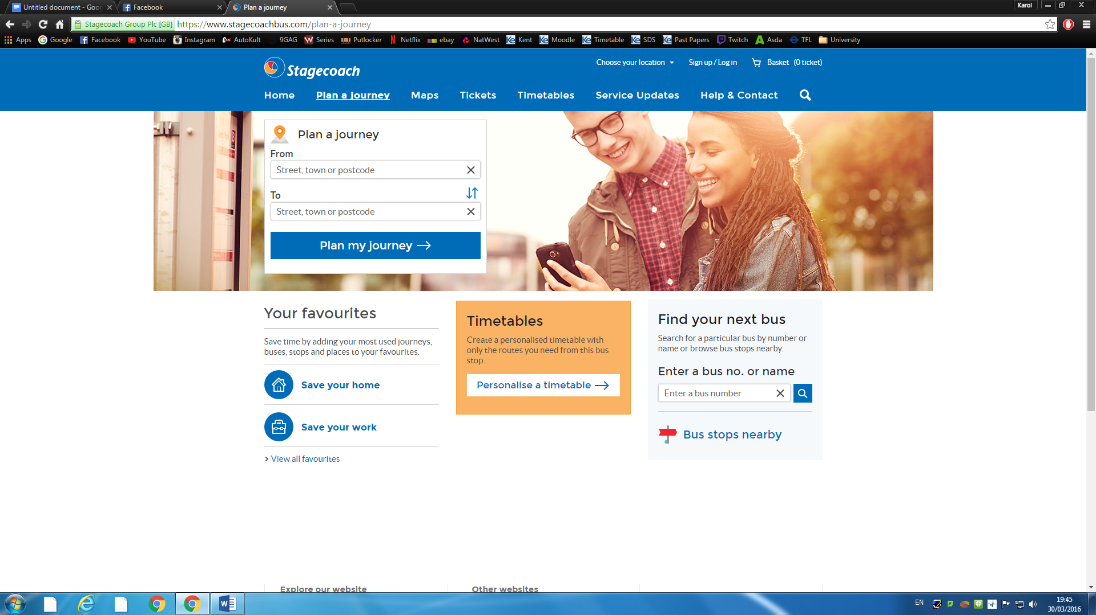

Stagecoach offers a Journey planner. The layout looks very similar to the basic layout offered by TFL’s journey planner offering the input for initial location, destination as well as date and time options.

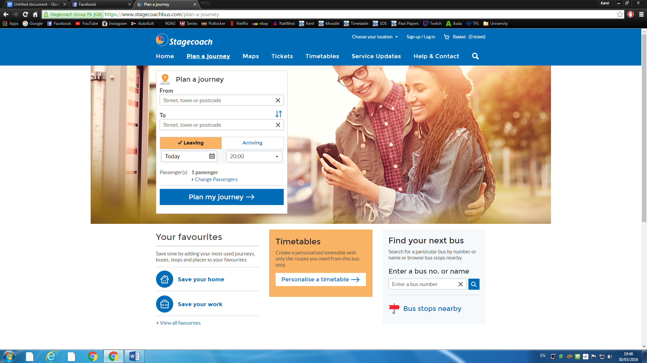

Date and time options are shows as soon as a user clicks on one of the text-boxes “From” and “To”.

This system is very minimalistic offering just the basic functionality for route planning. It is however enough as this website only deals with coach travel. I like its minimalistic layout which makes the planner extremely easy to use.

1. **Evaluation**

All 3 systems that I reviewed share many similarities. The input form for the start location, destination and date-time options are almost identical in every case. Looking at initial specification of our CO600 project, TFL’s journey planner is a system that will resemble Journey Organiser most accurately. I personally also like the TFL’s system. It has a basic design that extends to a more advanced layout. Advanced properties cover all possible combinations requests and restrictions that we could come up with.

This research largely aided my understanding of such systems. I have acquired a general idea of what the Journey Organiser’s website and app should look like. There will surely be adaptations and changes in the design as the project development progresses, however, we will always try to stick to design of the well-established route planning engines. This should minimalize the potential changes that will have to be made after final stages of user acceptance testing.